**SIR GAETAN**

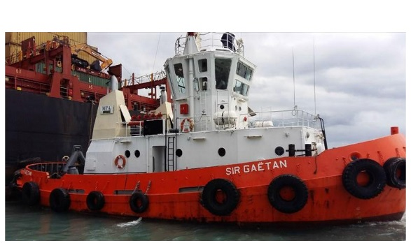

**IMO: -**

**MMSI:** 645443000

**Call Sign:** 3BIM

**Flag:** Mauritius [MU]

**AIS Vessel Type:** Tug

**Gross Tonnage: -**

**Deadweight: -**

**Length Overall x Breadth Extreme:** N/a

**Year Built: -**

**Status: Active**