SIR EDOUARD
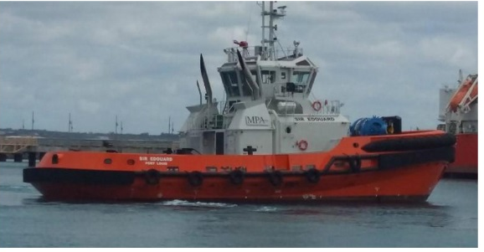

IMO: 9779044
MMSI: 645448000
Call Sign: 3BSU
Flag: Mauritius [MU]
AIS Vessel Type: Unspecified
Gross Tonnage: 497
Deadweight: 152 t
Length Overall x Breadth Extreme: 32m × 12.8m
Year Built: 2016
Status: Active

