**DA PATTEN**

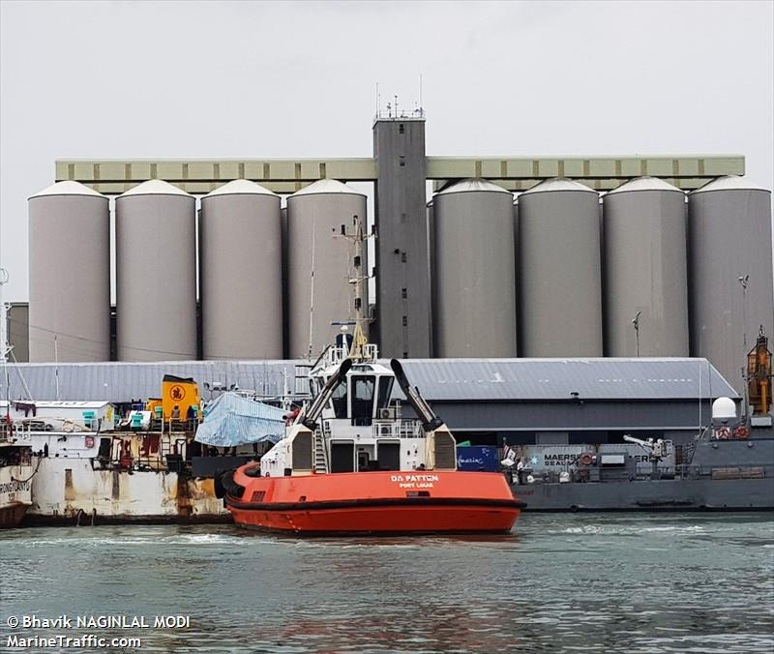

**IMO:** 9460710

**MMSI:** 645301000

**Call Sign:** 3BQZ

**Flag:** Mauritius [MU]

**AIS Vessel Type:** Unspecified

**Gross Tonnage:** 192

**Deadweight:** 150 t

**Length Overall x Breadth Extreme:** 24.55m × 10.7m

**Year Built:** 2009

**Status:** Active