SARAH
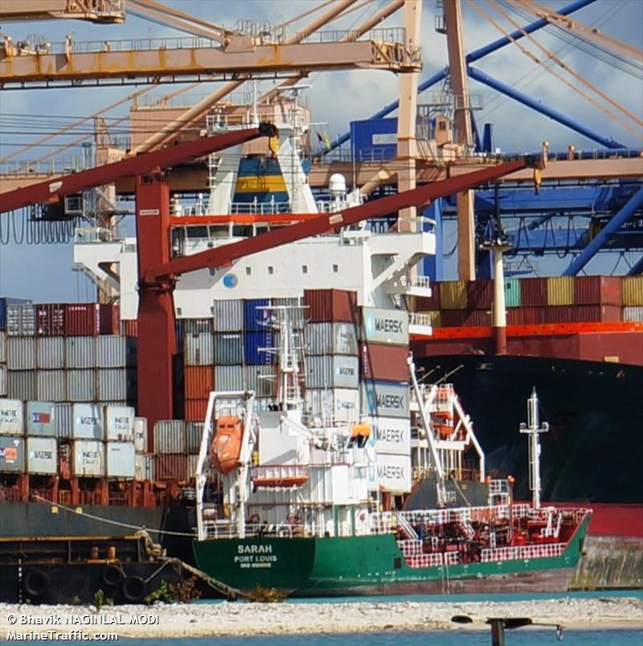

IMO: 9555591
MMSI: 645469000
Flag: Mauritius [MU]
Vessel Type: Tanker
Gross Tonnage: 1372
Deadweight: 1975 t
Length Overall x Breadth Extreme: 77m × 11m
Year Built: 2011

